




WORKWISE:AI-POWERED FACULTY WORKLOAD INTELLIGENCE
Faculty Workload & Time Allocation Assistant

Project Domain
[ Excel / Power BI with Copilot]

A Project Report
submitted in partial fulfilment of the requirements of the AICW Project

by:



Faculty Name
DR GAGAN DEEP CHADHA

Faculty Email
drgagandeep.nationalpgcollege@npgc.in
Guide
UMA MAHESHWARI

Institution:
[NATIONAL P G COLLEGE, LUCKNOW]

Year – 2026

ACKNOWLEDGEMENT
I take this opportunity to express my sincere and heartfelt gratitude to everyone who contributed, directly or indirectly to the successful completion of this project.
I am especially thankful to my supervisor, Uma Maheshwari, for her exceptional guidance, continuous support, and valuable insights throughout the project. Her constructive feedback, encouragement, and unwavering belief in our abilities played a vital role in shaping our work and bringing it to completion. Would like to thank Bharti Mam for her mentorship, inspiring sessions as it has been a constant source of learning.
I would like to extend my sincere appreciation to the Edunet Foundation, Microsoft, LinkedIn, and SAP for offering us this prestigious fellowship opportunity. The resources, training, and platform provided by them greatly enhanced our understanding of data analytics and AI, and enabled us to apply these skills in a practical and meaningful way.
We are also grateful to National PG College, Lucknow for providing the necessary infrastructure, resources, and a supportive environment that facilitated the successful execution of this project. Finally, I express our deepest thanks to my family and friends for their unwavering encouragement, patience, and moral support throughout this journey. Their belief in us has been a constant source of strength and motivation.

.

ABSTRACT OF THE PROJECT

This project is part of the AICW (Artificial Intelligence in the Contemporary World) Fellowship Program, a collaborative initiative by Edunet Foundation in partnership with Microsoft, LinkedIn, and SAP. The fellowship is designed to equip students with practical, hands-on skills in Artificial Intelligence, Data Analytics, and Business Intelligence tools.
The project, titled “WORKWISE: AI-Powered Faculty Workload Intelligence,” focuses on addressing the challenge of inefficient and non-transparent faculty workload management in higher education institutions. Traditional workload allocation methods often fail to consider the full range of faculty responsibilities, leading to imbalances and reduced efficiency.
The primary objective of this project is to develop a structured, data-driven approach to analyze and optimize faculty workload. A comprehensive dataset was created, incorporating multiple workload parameters such as teaching, research, administrative duties, mentoring, and evaluation tasks. Microsoft Excel was used for data cleaning, pre processing, and calculation of key metrics like total workload and workload percentage. Power BI was utilized to develop an interactive dashboard for visualizing workload distribution, while Microsoft Copilot was integrated to generate AI-assisted insights and recommendations. The analysis revealed significant variations in workload distribution and identified faculty members with excessive workload. The dashboard provided clear and actionable insights, supporting better decision-making.
In conclusion, the project demonstrates the effectiveness of combining data analytics and AI tools to improve transparency, fairness, and efficiency in faculty workload management, making it a valuable solution for academic institutions.

TABLE OF CONTENTS

Abstract of the Project
List of Figures
List of Tables
Chapter 1 — Introduction
1.1 Problem Statement
1.2 Motivation
1.3 Objectives
1.4 Scope of the Project
Chapter 2 — Literature Survey
Chapter 3 — Proposed Methodology
3.1 System Design
3.2 Modules / Components Used
3.3 Data Flow Diagram (DFD)
3.4 Advantages
3.5 Requirement Specification
Chapter 4 — Implementation and Results
4.1 Data Cleaning Results
4.2 Visualization / Output Results
4.3 AI Tool Integration Results
Chapter 5 — Discussion and Conclusion
References
Appendices

LIST OF FIGURES

Figure No. | Figure Title / Description | Page No.
Figure 1 | [Raw / uncleaned dataset screenshot] | 37
Figure 2 | [Cleaned dataset or validation summary screenshot] | 39
Figure 3 | [Main dashboard / report / output screenshot] | 30
Figure 4 | [Additional chart or visualization screenshot] | 41
Figure 5 | [AI tool (Copilot / Chatbot) in use screenshot] | 40
Figure 6 | [DFD Level 0 — Context Diagram] | 21
Figure 7 | [DFD Level 1 — Detailed Process Flow] | 22

LIST OF TABLES

Table No. | Table Title / Description | Page No.
Table 1 | [Raw dataset summary — field names, data types, row count] | 37
Table 2 | [Cleaned dataset summary — issues found and fixed] | 39
Table 3 | [Hardware Requirements] | 23
Table 4 | [Software Requirements] | 23
Table 5 | [Key findings / results summary] | 26-31

CHAPTER 1
Introduction
This chapter introduces the project undertaken as part of the AICW Fellowship Program, titled “WORKWISE: AI-Powered Faculty Workload Intelligence.” The project falls within the domain of Human Resource Management and Data Analytics, with a focus on improving faculty workload management in higher education institutions using modern analytical and AI-driven tools.
In academic institutions, faculty members are required to perform a wide range of responsibilities beyond classroom teaching. These include research activities, mentoring students, administrative duties, examination responsibilities, and institutional contributions. However, in many cases, these responsibilities are either partially recorded or managed through informal systems, resulting in a lack of transparency and inefficiency in workload allocation.
This project addresses these challenges by developing a structured dataset, applying analytical techniques using Microsoft Excel, and creating interactive visualizations using Power BI. Additionally, Microsoft Copilot is integrated to generate AI-assisted insights, making the analysis more efficient and actionable. The chapter further elaborates on the problem being addressed, the motivation behind the project, and its relevance in the context of modern data-driven decision-making.

1.1 Problem Statement
Faculty workload management in higher education institutions is often based on subjective judgment rather than objective data. While teaching hours are typically documented, several other important responsibilities such as mentoring, administrative work, research activities, and evaluation duties are either underrepresented or not quantified at all. This creates a significant gap between the actual workload performed by faculty members and the workload that is formally recorded.
As a result, institutions face multiple challenges. Some faculty members become overloaded with excessive responsibilities, while others may have comparatively balanced or lower workloads. This imbalance leads to reduced teaching effectiveness, increased stress levels among faculty, and potential decline in overall institutional performance.
The problem is particularly significant because it directly affects key stakeholders, including faculty members, students, and academic administrators. Overloaded faculty may not be able to dedicate sufficient time to teaching and mentoring, which can negatively impact student learning outcomes. At the same time, administrators lack reliable data to make informed decisions regarding workload distribution, resource allocation, and performance evaluation.
Existing approaches to workload management are often manual and lack standardization. They rely heavily on basic record-keeping or assumptions rather than comprehensive data analysis. Moreover, these systems do not leverage modern tools such as business intelligence platforms or artificial intelligence for deeper insights and automation.
Therefore, there is a clear need for a structured, data-driven system that can accurately capture all aspects of faculty workload, analyze workload distribution, and provide actionable insights for fair and efficient allocation. This project aims to address this gap by combining data analytics and AI tools to create a transparent and effective workload management framework.

1.2 Motivation
The motivation behind this project stems from the growing need to bring transparency, fairness, and efficiency into faculty workload management systems. In many academic institutions, workload allocation is still influenced by subjective decisions and incomplete data, which can lead to dissatisfaction among faculty members and inefficiencies in institutional operations.
From a practical perspective, this project provides an opportunity to apply data analytics and business intelligence tools to solve a real-world problem in the education sector. The use of Microsoft Excel for data processing, Power BI for visualization, and Microsoft Copilot for AI-assisted analysis demonstrates how modern technologies can be integrated to enhance decision-making processes.
This project is also aligned with current industry trends, where organizations are increasingly adopting data-driven approaches and artificial intelligence to improve operational efficiency. The ability to analyze large datasets, generate insights, and automate reporting is becoming a critical skill in fields such as HR analytics and business intelligence.
On a personal level, the project offers valuable hands-on experience in working with real-world data, building dashboards, and using AI tools effectively. It helps in developing practical skills that are highly relevant in today’s data-centric professional environment.
Furthermore, the potential applications of this project extend beyond academic institutions. The methodology can be adapted to other domains where workload distribution and resource management are important, such as corporate HR systems, project management, and service industries.
Overall, the project is motivated by the need to bridge the gap between traditional workload management practices and modern data-driven solutions, thereby contributing to improved efficiency, fairness, and transparency in organizational processes.

1.3 Objectives
The primary objective of this project is to design and implement a structured, data-driven framework for analyzing and optimizing faculty workload in higher education institutions. The study aims to move beyond traditional perception-based workload allocation methods and introduce a measurable and transparent system.
The specific objectives of the project are as follows:
- To develop a comprehensive and structured faculty workload dataset that systematically captures all major academic and non-academic responsibilities, including teaching, research, mentoring, evaluation, and administrative tasks.
- To enhance the reliability and consistency of the dataset through data cleaning, pre processing, and validation techniques using Microsoft Excel.
- To design and compute key performance indicators such as total workload, workload percentage, and workload balance status in order to quantify faculty effort in a standardized manner.
- To conduct a detailed analytical assessment of workload distribution across faculty members and departments, with the objective of identifying patterns of imbalance, overload, and inefficiency.
- To develop an interactive and visually intuitive dashboard using Power BI that enables stakeholders to monitor workload distribution and make informed decisions.
- To integrate artificial intelligence tools, specifically Microsoft Copilot, to generate automated summaries, detect anomalies, and provide data-driven recommendations for workload redistribution.
- To propose a scalable and adaptable workload management model that can be implemented across higher education institutions to improve transparency, equity, and operational efficiency.

1.4 Scope of the Project
The scope of this project is defined within the domain of faculty workload management in higher education institutions, with a specific focus on analyzing and optimizing workload distribution using data analytics and AI-assisted tools.
The project is based on a structured faculty workload dataset developed for analytical purposes. The dataset includes information related to various academic and administrative activities performed by faculty members, such as weekly teaching hours, research contributions, mentoring responsibilities, examination duties, evaluation work, and administrative tasks. This dataset serves as the primary input for analysis and is designed to represent a realistic academic workload environment.
The analytical framework of the project is implemented using Microsoft Excel, Power BI, and Microsoft Copilot. Excel is used for data cleaning, preprocessing, and calculation of key metrics such as total workload and workload percentage. Power BI is utilized for creating interactive dashboards and visual representations of workload distribution, enabling better interpretation of the data. Microsoft Copilot is integrated to generate AI-assisted summaries, identify workload patterns, and provide recommendations for workload redistribution.
The scope of analysis is primarily focused on descriptive and diagnostic analytics. It includes data cleaning, validation, computation of workload indicators, identification of workload imbalance, and visualization of insights through dashboards. The project emphasizes understanding existing workload patterns rather than predicting future trends.
However, certain aspects are intentionally kept outside the scope of this project. The study does not include real-time data integration, automated data collection from institutional systems, or the use of advanced machine learning and predictive analytics models. Additionally, the project does not implement a fully automated workload allocation system but rather provides analytical insights and recommendations based on the available data. It is important to note that this project is developed as part of the AICW Fellowship Program and is intended for academic demonstration and learning purposes. While the methodology and framework are scalable and can be adapted for real-world applications, the current implementation is not designed as a production-level system.
Overall, the scope of the project is centered on demonstrating how data analytics and AI tools can be effectively used to analyze, visualize, and improve faculty workload management in a structured and transparent manner
The overall scope is-
- This project covers a structured faculty workload dataset that includes multiple parameters such as weekly teaching hours, research work, administrative duties, mentoring, examination duties, and evaluation activities of faculty members in higher education institutions.
- The dataset is designed to represent a realistic academic environment and is used to analyze workload distribution among 50 faculty members across different departments.
- The tools used in this project are limited to Microsoft Excel, Power BI, and Microsoft Copilot. Excel is used for data cleaning and calculations, Power BI for visualization and dashboard creation, and Copilot for AI-assisted insights and summaries.
- The analysis focuses on data cleaning, preprocessing, calculation of workload metrics (Total Workload, Workload Percentage, Status), identification of overloaded faculty, and visualization of workload distribution using charts and dashboards.
- The project also includes AI-based analysis, where Microsoft Copilot is used to generate summaries, detect patterns, and provide recommendations for workload redistribution.
- The scope is limited to descriptive and diagnostic analysis, and does not include predictive modeling or advanced machine learning techniques.
- The project does not include real-time data integration, automated data collection from institutional systems, or live dashboard updates.
- The study does not implement a fully automated workload allocation system but focuses on analysis and recommendation generation based on the dataset.

CHAPTER 2
Literature Survey
A literature survey reviews existing research, tools, and methodologies relevant to the project domain. It helps identify gaps that the current project aims to address.
2.1 Existing Work and Research
Faculty workload has become a critical area of study in higher education due to its direct impact on teaching effectiveness, research productivity, and overall institutional performance. Traditionally, faculty workload models have been centered around teaching hours; however, recent research highlights that such approaches fail to capture the full scope of academic responsibilities. Faculty members are increasingly engaged in diverse activities such as research, mentoring, administrative duties, and institutional service, making workload inherently multidimensional (O’Meara et al., 2019).
Several studies emphasize that the lack of a comprehensive workload measurement system leads to inaccurate representation of faculty effort. When non-teaching responsibilities are not adequately accounted for, institutions risk overburdening certain faculty members while underutilizing others. This imbalance not only affects individual performance but also impacts organizational efficiency and fairness (Mushabe et al., 2022).
Workload equity has also emerged as a significant concern in academic research. According to O’Meara et al. (2019), workload distribution is often uneven, with some faculty members disproportionately handling administrative and mentoring responsibilities. Such inequities can lead to reduced job satisfaction, limited research opportunities, and long-term career implications for faculty members.
Furthermore, studies on faculty performance indicate that excessive workload can negatively influence both teaching quality and research output. High workload levels have been associated with increased stress, burnout, and reduced engagement in scholarly activities (Ramya & Muthumari, 2023). This highlights the importance of developing systems that not only measure workload accurately but also ensure its balanced distribution.
In recent years, there has been a shift toward data-driven approaches in workload management. Researchers suggest that the use of structured datasets and analytical tools can significantly improve the accuracy and transparency of workload assessment. Business intelligence tools such as Power BI enable institutions to visualize workload patterns and identify imbalances effectively (Ludwig-Beymer, 2024).
Additionally, the integration of artificial intelligence in data analytics has introduced new possibilities for automating workload analysis. AI tools can assist in generating insights, detecting anomalies, and supporting decision-making processes. However, existing literature indicates that the practical application of AI tools such as Microsoft Copilot in faculty workload management is still limited and underexplored.
Despite the availability of analytical tools and theoretical frameworks, many institutions continue to rely on manual or semi-structured systems for workload allocation. These approaches lack scalability, consistency, and real-time insight generation. Therefore, there is a clear need for integrated systems that combine data analytics, visualization, and AI capabilities.
The present project addresses this gap by developing a structured workload dataset, applying Excel-based analysis, creating interactive dashboards using Power BI, and integrating AI-assisted insights through Microsoft Copilot. This approach aligns with emerging trends in data-driven decision-making and provides a practical, scalable solution for faculty workload management.

2.2 Tools and Technologies Review

- Microsoft Excel —used for data cleaning, transformation, and basic visualization. Pivot tables, conditional formatting, and data validation are commonly used techniques.
- Microsoft Power BI — a business analytics tool that provides interactive visualizations and business intelligence capabilities with an interface simple enough for end users to create their own reports and dashboards.
- Microsoft Copilot (AI) — an AI assistant integrated into Microsoft 365 tools that helps automate tasks, generate summaries, and assist with data analysis using natural language prompts.
- AI Chatbots (ChatGPT, Gemini) — generative AI tools used for content creation, marketing copy, report generation, and prompt-driven analysis.

2.3 Gaps Identified
- Lack of Comprehensive Workload Measurement Models
Most existing studies focus primarily on teaching hours and fail to incorporate the full range of faculty responsibilities such as mentoring, administrative duties, and evaluation work. This results in an incomplete representation of actual workload.
- Limited Focus on Workload Equity and Distribution
Although workload imbalance is widely acknowledged, there is insufficient practical implementation of systems that ensure fair and equitable distribution of responsibilities among faculty members.

- Minimal Use of Data Analytics Tools in Practice
While research supports data-driven decision-making, many institutions still rely on manual or semi-structured methods rather than using tools like Excel and Power BI for systematic workload analysis and visualization.

- Lack of Integration of AI in Workload Management
The application of AI tools such as Microsoft Copilot in faculty workload analysis is still in its early stages, with very limited real-world implementation for generating insights, detecting patterns, or supporting decision-making.

- Absence of Real-Time and Dynamic Workload Monitoring Systems
Existing approaches do not provide real-time tracking or dynamic updates of faculty workload, making it difficult for institutions to respond quickly to workload imbalances.

- Gap Between Theoretical Models and Practical Implementation
Most literature discusses conceptual frameworks and policies for workload management, but there is a lack of simple, scalable, and user-friendly systems that can be easily implemented in real academic environments.

Overall gaps identified-
- Most existing literature focuses on complex machine learning approaches; simpler, tool-based solutions for non-technical users are underexplored.
- There is limited documentation on integrating AI Copilot with Excel/Power BI for domain-specific analysis in the context of student projects.
- Prompt engineering best practices for business use cases are still evolving and lack standardized frameworks.

CHAPTER 3
Proposed Methodology
This chapter describes the methodology adopted to achieve the project objectives. It covers the system design, modules used, data flow, advantages, and requirement specifications.
3.1 System Design
The overall design of this project follows a structured, data-driven approach to analyze and optimize faculty workload. The system is designed to transform raw workload data into meaningful insights through a sequence of stages including data collection, preprocessing, analysis, and visualization. This ensures a clear flow of information from input to output, enabling effective decision-making.
The workflow of the system is described as follows:

Data Source / Input
The input for this project consists of a structured faculty workload dataset created in Microsoft Excel. The dataset includes information for approximately 50 faculty members across different departments. It captures multiple dimensions of workload such as teaching hours, research activities, administrative duties, mentoring responsibilities, examination duties, evaluation work, and meeting hours.This dataset serves as the foundational input for the entire analysis and is designed to simulate real-world academic workload conditions.

Data Cleaning
Before analysis, the dataset undergoes a data cleaning and preprocessing phase to ensure accuracy and consistency. This involves verifying that all workload components are properly recorded and formatted.Key steps include checking for missing or inconsistent values, standardizing numerical formats, and ensuring that all activity fields are correctly aligned. Any discrepancies in workload entries are corrected to maintain uniformity across the dataset. This step ensures that the subsequent analysis is based on reliable and error-free data.

Analysis / Processing
The cleaned dataset is then analyzed using Microsoft Excel and Power BI. In Excel, formulas are applied to compute key workload metrics such as total workload, workload percentage, and workload status (balanced or overloaded). Pivot tables are used to summarize data and identify patterns across different faculty members and departments.
Further analysis is performed in Power BI, where the dataset is transformed into a structured data model. Various measures and aggregations are used to analyze activity-wise workload distribution and compare faculty performance.Additionally, Microsoft Copilot is utilized to generate AI-assisted insights. It helps in summarizing key findings, identifying outliers, and suggesting possible workload redistribution strategies.

Visualization / Output
The final output of the system is presented in the form of an interactive Power BI dashboard. The dashboard includes visual elements such as bar charts, pie charts, and KPI indicators that display total workload, activity-wise contribution, and faculty-wise comparisons.The visualization enables users to easily identify workload imbalances, understand distribution patterns, and make informed decisions. In addition to the dashboard, a detailed analytical report is generated, supported by AI-generated summaries from Microsoft Copilot.
Overall, the system transforms raw workload data into clear, visual, and actionable insights, demonstrating the effectiveness of combining data analytics and AI tools in faculty workload management

3.2 Modules / Components Used
The proposed system for faculty workload analysis is divided into several functional modules, each responsible for a specific stage in the data processing and analysis pipeline. These modules work together to transform raw workload data into meaningful insights and visual outputs.

Module 1: Data Ingestion
This module is responsible for collecting and loading the faculty workload dataset into the system. The dataset is created and stored in Microsoft Excel and includes detailed information about faculty activities such as teaching hours, research work, administrative duties, mentoring, evaluation, and examination responsibilities.The data ingestion process ensures that all relevant information is organized in a structured tabular format, making it suitable for further processing and analysis.

Module 2: Data Cleaning and Preprocessing
In this module, the raw dataset is prepared for analysis by ensuring data accuracy, consistency, and completeness. The cleaning process involves verifying that all workload parameters are correctly entered, checking for missing or inconsistent values, and standardizing formats across different fields.This step is crucial because any errors or inconsistencies in the dataset can lead to incorrect analysis and misleading results. By ensuring high data quality, this module lays the foundation for reliable insights.

Module 3: Data Analysis and Computation
The analysis module focuses on processing the cleaned data to generate meaningful metrics. Using Microsoft Excel, formulas are applied to calculate key indicators such as total workload, workload percentage, and workload status (e.g., balanced or overloaded).Pivot tables are used to summarize the data and identify patterns across faculty members and departments. This module helps in transforming raw numerical data into interpretable information that highlights workload distribution and imbalances.

Module 4: Visualization and Dashboard Development
This module involves the creation of interactive visualizations using Power BI. The processed dataset is imported into Power BI, where it is used to build dashboards that display workload distribution through charts, graphs, and key performance indicators.The dashboard provides a user-friendly interface that allows stakeholders to easily interpret the data, compare faculty workloads, and identify trends. It plays a critical role in converting analytical results into actionable insights.

Module 5: AI Integration and Insight Generation
This module incorporates the use of Microsoft Copilot to enhance the analytical process through artificial intelligence. Copilot is used to generate summaries of the dataset, identify patterns and outliers, and suggest recommendations for workload redistribution.The integration of AI reduces manual effort, improves the speed of analysis, and provides additional perspectives that may not be easily identified through traditional methods.

Module 6: Reporting and Documentation
The final module focuses on presenting the results in the form of a structured report. The insights generated from Excel analysis, Power BI dashboards, and AI tools are compiled into a comprehensive document.This report provides a detailed explanation of the methodology, findings, and recommendations, making it suitable for academic submission and evaluation.

3.3 Data Flow Diagram (DFD)
DFD LEVEL 0 (Context Diagram)

+-----------------------+
| Faculty Dataset |
| (Excel Input Data) |
+-----------+-----------+
|
v
+-------------------------------+
| Faculty Workload Analysis |
| System |
| (Excel + Power BI + Copilot) |
+-----------+-------------------+
|
v
+----------------------------------------------+
| Dashboard | Reports | AI Insights | Results |
| (Power BI Output & Analysis Summary) |
+----------------------------------------------+

DFD LEVEL 1 (Detailed Process Flow)
+-----------------------------+
| 3. Analysis & AI Processing |
| - Excel formulas |
| - Pivot tables |
| - Copilot insights |
+----------+------------------+
|
v
+-----------------------------+
| 4. Visualization & Reporting|
| - Power BI Dashboard |
| - Charts & KPIs |
+----------+------------------+
|
v
+--------------------------------------+
| Final Output |
| - Dashboard |
| - Reports |
| - AI Recommendations |
+--------------------------------------+

3.4 Advantages

- Automates data cleaning, validation, and workload calculations, reducing manual effort and errors.
- Provides a comprehensive workload assessment by including teaching, research, mentoring, administrative, evaluation, and examination activities.
- Enables clear and interactive visualization of workload distribution through Power BI dashboards.
- Utilizes AI (Microsoft Copilot) for automated insight generation, pattern detection, and recommendations.
- Enhances transparency and fairness in workload allocation using measurable indicators.
- Identifies overloaded faculty members, enabling timely workload redistribution.
- Scalable and adaptable to larger datasets or other domains like HR workload analysis.
- Cost-effective as it uses widely available tools like Excel, Power BI, and Copilot.
- Supports data-driven decision-making for administrators and stakeholders.
- Provides a foundation for future enhancements such as real-time analytics and automation.

3.5 Requirement Specification
Hardware Requirements
Component | Specification
Processor | Intel Core i3
RAM | Minimum 4 GB (8 GB recommended)
Storage | Minimum 50 GB free disk space
Display | 1366 x 768 resolution or higher
Internet | Required for Copilot / Chatbot access

Software Requirements
Software | Details
Operating System | Windows 10
Microsoft Excel | Microsoft 365 (Excel with Copilot) / Excel 2019+
Power BI Desktop | Latest version (free download from Microsoft)
Microsoft Copilot | Integrated via Microsoft 365 subscription
AI Chatbot | ChatGPT / Google Gemini / Microsoft Copilot (web)
Web Browser | Google Chrome / Microsoft Edge (latest version)

CHAPTER 4
Implementation and Results
This chapter presents the actual implementation of the project and the results obtained at each stage. Screenshots of dashboards, cleaned datasets, or generated content should be inserted where indicated.
4.1 Data Cleaning Results
During initial inspection of the dataset, several potential issues were identified:
- Inconsistent data entry formats across workload columns
- Minor formatting inconsistencies in numerical values
- Possibility of calculation errors in workload totals
- Lack of standardized structure for analysis-ready format
The following steps were performed using Microsoft Excel to clean and prepare the dataset:
- Verified all workload fields (teaching, research, admin, etc.) for completeness and correctness
- Standardized numerical formats across all columns
- Ensured consistency in department names and categorical values
- Applied formulas to correctly calculate Total Workload
- Validated calculated values to avoid manual errors
- Structured the dataset in a tabular format suitable for pivot tables and Power BI integration
These steps ensured that the dataset was clean, consistent, and ready for further analysis. Cleaned Dataset Size: After cleaning and validation, the dataset remained 50 rows with the same number of columns, but with improved consistency, accuracy, and analysis-readiness

4.2 Visualization / Output Results

The project utilizes Power BI to transform the processed dataset into interactive visualizations and dashboards. These visual outputs play a crucial role in presenting workload patterns in a clear and interpretable manner, enabling effective analysis and decision-making.
The key visualizations developed in this project are described below:

• Dashboard -Overall Workload Distribution
This visualization represents the distribution of faculty based on workload status, categorizing them into Balanced and Overloaded groups. It provides a quick overview of how workload is distributed across the institution and highlights the proportion of faculty experiencing excessive workload.
• Dashboard - Activity-wise Workload Distribution
This chart illustrates the contribution of different workload components such as teaching, research, administrative duties, mentoring, evaluation, and examination work. It helps in identifying which activities consume the most time and contribute significantly to the overall workload.
• Dashboard : Faculty-wise Workload Comparison
This visualization compares the total workload of individual faculty members. It helps in identifying outliers, particularly those with significantly higher workload, and supports decision-making for workload redistribution.
• Dashboard -Department-wise Workload Analysis
This chart provides a comparative view of workload distribution across different departments. It helps in understanding whether workload imbalance exists at the departmental level and supports better allocation of responsibilities.
• Dashboard - Key Performance Indicators (KPIs)
The dashboard includes KPI cards displaying important metrics such as total workload hours, number of faculty members, and workload distribution percentages. These indicators provide a quick summary of the overall dataset.
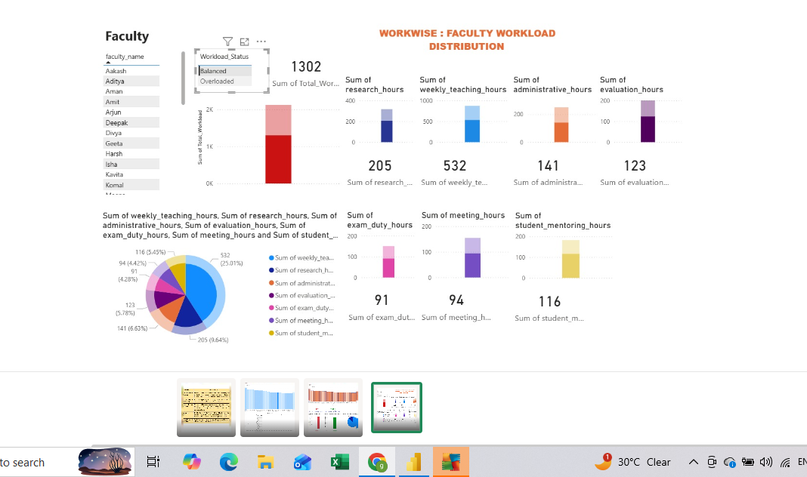

The Power BI dashboard integrates all these visual elements into a single interactive interface, allowing users to filter and explore the data dynamically. This enhances the usability of the system and supports data-driven decision-making.

4.3 AI Tool Integration Results
The integration of artificial intelligence in this project was carried out using Microsoft Copilot, which enhanced the analytical capabilities and efficiency of the overall system. AI was primarily used to assist in generating insights, summarizing findings, and supporting decision-making.
• Tool Used:
Microsoft Copilot was used as the primary AI tool for this project. It was integrated with Microsoft Excel and other tools to assist in data interpretation and content generation.
• Prompts Used:
Several structured prompts were used to extract meaningful insights from the dataset. Examples include:
- “Analyze faculty workload distribution and identify overloaded faculty members.”
- “Summarize key findings from the dataset.”
- “Suggest strategies to balance workload among faculty members.”
These prompts helped in guiding the AI tool to generate relevant and context-specific outputs.
• Output Quality:
The outputs generated by Microsoft Copilot were clear, structured, and relevant to the dataset. The AI tool was able to quickly identify patterns such as workload imbalance, highlight faculty members with excessive workload, and provide concise summaries of key findings.
The quality of the output was consistent and required minimal manual refinement, making it a useful support tool in the analysis process.
• How AI Enhanced the Project:
The integration of AI significantly improved the efficiency and depth of the analysis. It reduced the time required to generate summaries and insights, which would otherwise take considerable manual effort.
Additionally, AI helped in identifying patterns and relationships within the data that may not be immediately visible through traditional analysis. It also assisted in generating recommendations for workload redistribution, thereby adding value to the overall project.

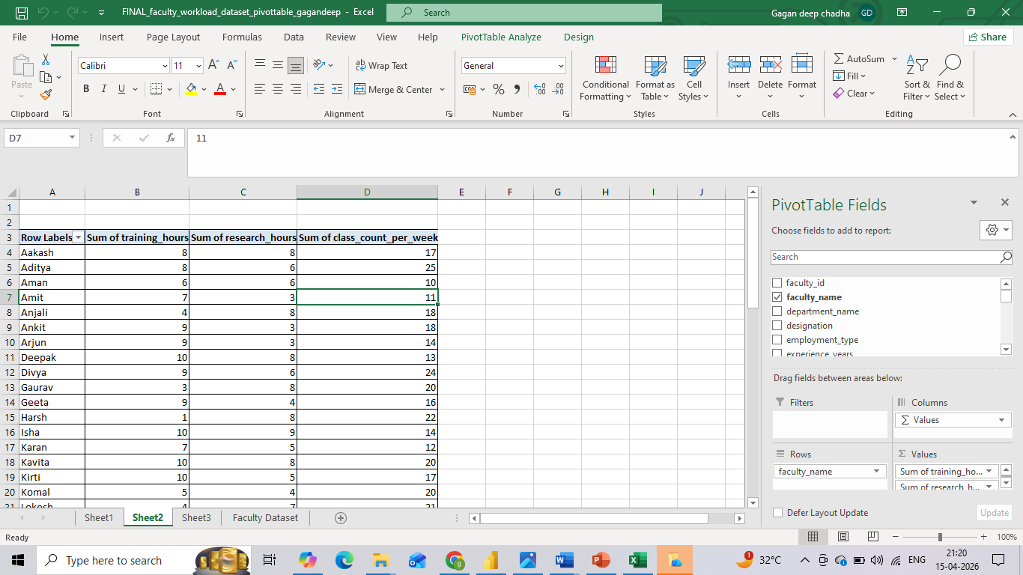

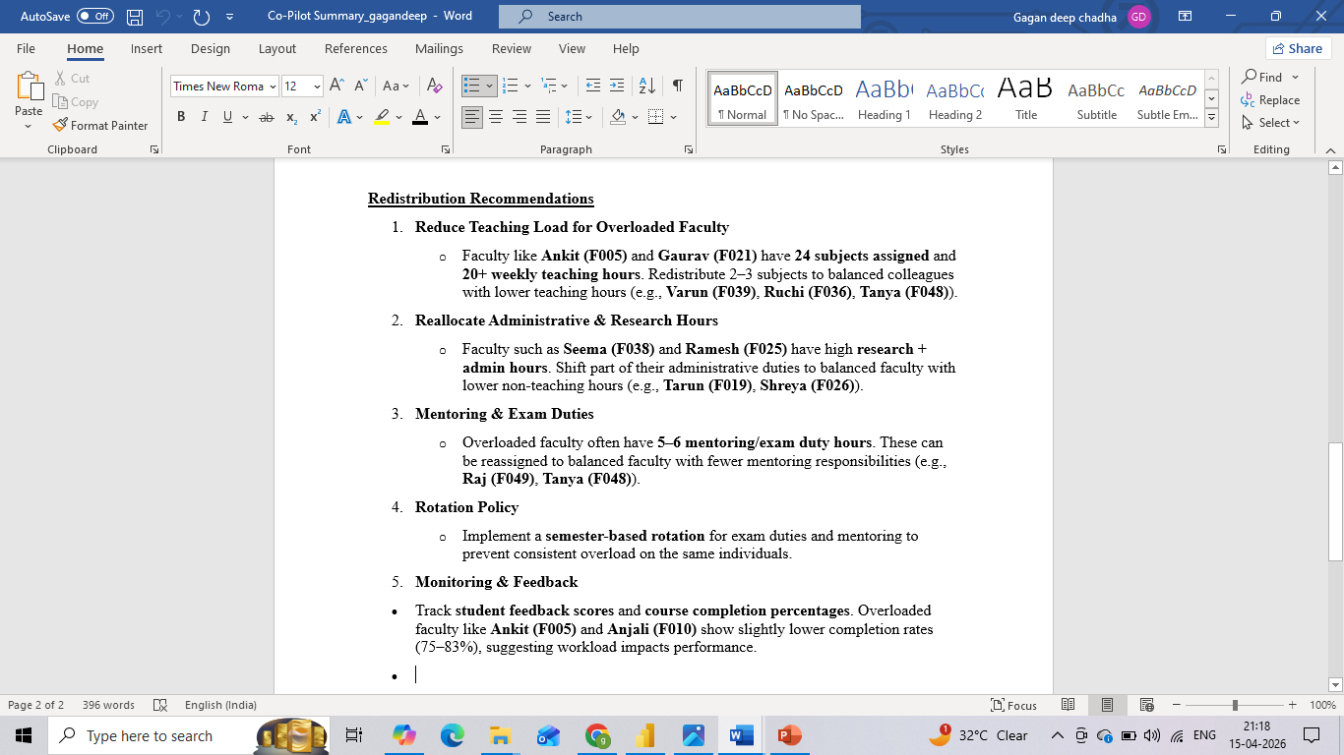
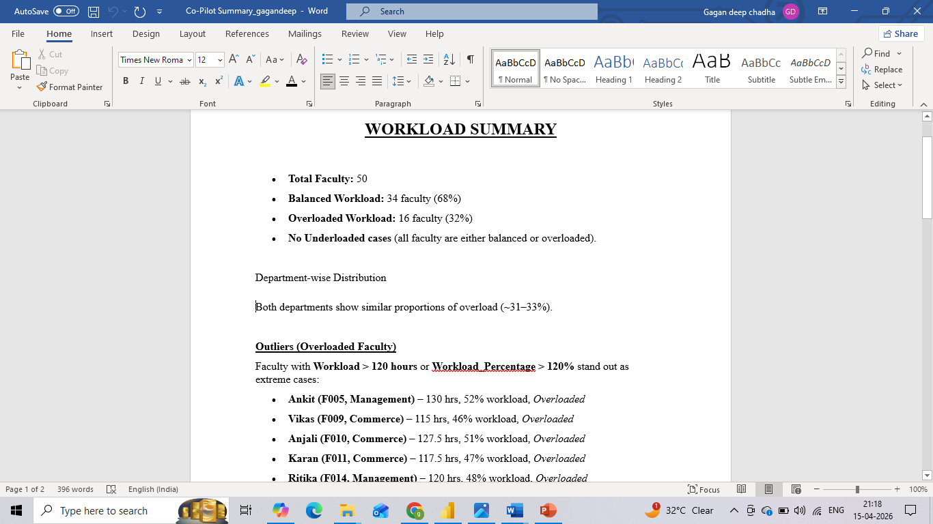

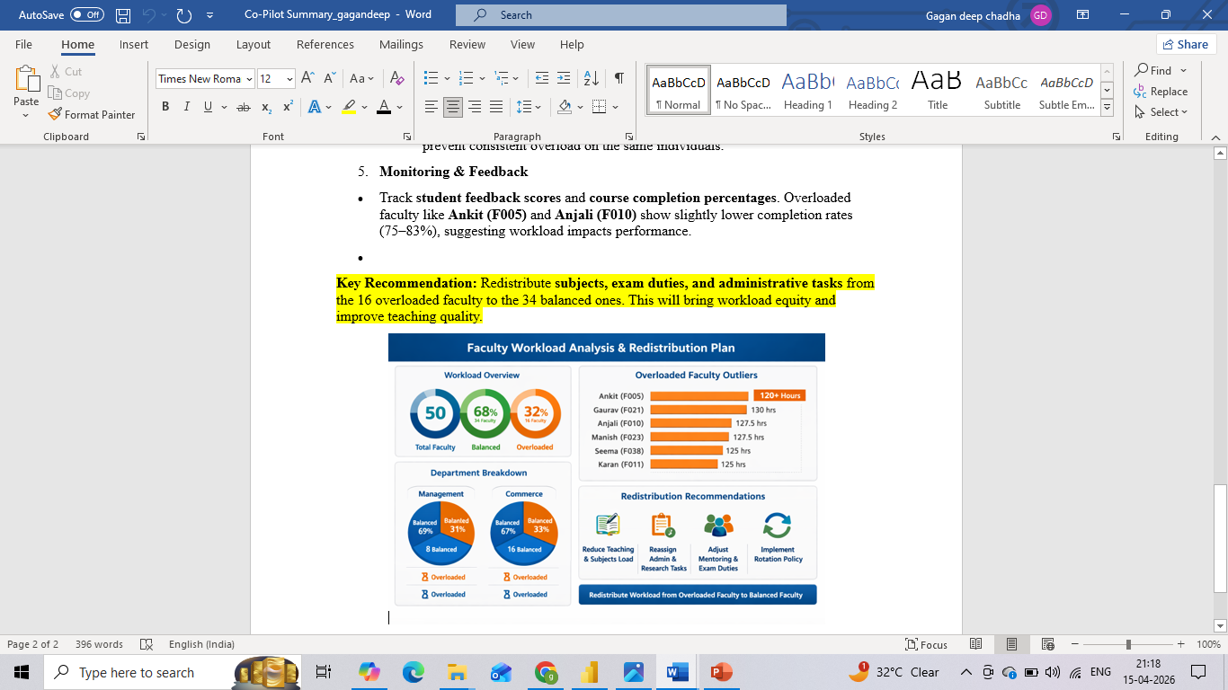

CHAPTER 5
Discussion and Conclusion
5.1 Key Findings
- The structured analysis of the faculty workload dataset revealed that workload distribution is uneven, with a noticeable number of faculty members categorized as overloaded based on total workload and workload percentage calculations.
- The inclusion of multiple workload parameters such as teaching, research, administrative duties, mentoring, and evaluation provided a more accurate and holistic assessment of faculty responsibilities compared to traditional methods.
- The Power BI dashboard clearly highlighted faculty-wise workload variations, making it easy to identify individuals with significantly higher workload and enabling better decision-making for workload redistribution.
- Activity-wise analysis showed that teaching and administrative duties contribute the most to total workload, indicating key areas where optimization efforts should be focused.
- The use of Excel formulas and pivot tables ensured accurate calculation of workload metrics, reducing manual errors and improving the reliability of results.
- Integration of Microsoft Copilot significantly improved efficiency by automating insight generation and summarizing key patterns, reducing the time required for analysis and reporting.
- The visualizations and KPI indicators provided clear, easy-to-understand insights for stakeholders, enhancing transparency in workload distribution.
- The project demonstrated that a data-driven approach can effectively replace subjective workload allocation methods, leading to more balanced and fair distribution of responsibilities.

5.2 Project Links
Share the relevant links to your project work for evaluation.
- GitHub Link of the Project: https://github.com/gdkc1711-design/DR-GAGAN-DEEP-CHADHA

- Video Recording of Project Demonstration: https://docs.google.com/presentation/d/1WomrTGGNuB3_RLV1dYS3rDvlKpDu4NO4/edit?usp=sharing&ouid=115957784491685477270&rtpof=true&sd=true

5.3 Limitations
- The project is based on a manually created sample dataset, which may not fully represent the complexity and variability of real-world faculty workload scenarios.
- The dataset size is limited (50 faculty records), which may restrict the scalability and generalization of insights to larger institutions.
- Microsoft Copilot usage was limited to basic insight generation and summarization, and more advanced AI capabilities could not be fully explored due to access and feature constraints.
- The system does not support real-time data integration or automatic updates, as the dataset is static and manually maintained in Excel.
- The analysis is limited to descriptive and diagnostic insights, and does not include predictive modeling or advanced machine learning techniques for forecasting workload trends.
- The project does not implement a fully automated workload allocation system, and recommendations are based on analysis rather than automated decision-making.
- The Power BI dashboard depends on manual data refresh and does not include live connectivity with institutional databases.
- Some workload factors such as qualitative aspects (teaching quality, research impact, stress levels) are not captured, as the analysis is based only on quantitative data.

5.4 Future Work
In the future, this project can be enhanced by integrating real-time data pipelines using tools like Power Automate or APIs to enable automatic updates and live monitoring of faculty workload. Advanced techniques such as machine learning can be applied for workload forecasting, anomaly detection, and trend analysis. The system can also be extended by developing a web-based or Power Apps interface for better accessibility among non-technical users. Expanding the dataset to include multiple institutions and incorporating additional parameters like student feedback, research impact, and performance indicators can provide deeper insights. Furthermore, the development of a standardized AI prompt library, integration with institutional databases, and implementation of an automated workload allocation system can significantly improve efficiency and scalability, making the solution more robust and suitable for real-world applications.
- Integrate real-time data pipelines using tools such as Power Automate or API connections to enable automatic data updates and live workload monitoring.
- Apply machine learning techniques such as workload forecasting, anomaly detection, and trend analysis to predict future workload patterns and optimize allocation.
- Develop a web-based interface or Power Apps solution to make the system more accessible for non-technical users such as administrators and faculty members.
- Expand the dataset to include larger and more diverse data sources, such as multiple institutions or departments, for more comprehensive analysis.
- Incorporate additional parameters such as faculty performance indicators, student feedback scores, and research impact metrics for deeper insights.
- Develop a standardized AI prompt library for Microsoft Copilot to ensure consistent and efficient insight generation across similar projects.
- Implement a fully automated workload allocation system that can recommend or assign tasks based on workload balance and predefined rules.
- Enhance the Power BI dashboard with advanced interactive features, drill-down analysis, and role-based access control.
- Integrate the system with institutional databases or ERP systems for seamless data flow and centralized management.

5.5 Conclusion
The project “WORKWISE: AI-Powered Faculty Workload Intelligence” successfully addressed the issue of unstructured and non-transparent faculty workload management by implementing a systematic, data-driven approach. By developing a comprehensive faculty workload dataset and utilizing Microsoft Excel for data processing, Power BI for visualization, and Microsoft Copilot for AI-assisted analysis, the project demonstrated how workload data can be transformed into meaningful and actionable insights. The findings highlighted significant variations in workload distribution and emphasized the importance of considering multiple dimensions such as teaching, research, administrative duties, and mentoring for accurate evaluation. The interactive dashboard and AI-generated summaries enabled clear understanding and supported informed decision-making for workload optimization. All the objectives outlined in the project were effectively achieved. Overall, the project contributes to improving transparency, fairness, and efficiency in faculty workload allocation and showcases the practical application of data analytics and AI in academic management systems. The fellowship experience also enhanced practical skills in data handling, visualization, and AI integration, making the project highly relevant for real-world implementation.
REFERENCES

- Microsoft Corporation. Microsoft Excel Documentation. Available at: https://support.microsoft.com/en-us/excel
- Microsoft Corporation. Power BI Documentation. Available at: https://learn.microsoft.com/en-us/power-bi/
- Microsoft Corporation. Microsoft Copilot — AI-Powered Productivity. Available at: https://copilot.microsoft.com
- Edunet Foundation. AICW Fellowship Program Guidelines. 2026.
- O’Meara, K., Kuvaeva, A., & Nyunt, G. (2019). Faculty workload equity: A review of research and implications for practice. Journal of Higher Education.

- Mushabe, C., Nansubuga, F., & Ssekiziyivu, B. (2022). Reconceptualizing faculty workload as a measure of motivation and performance. Social Sciences & Humanities Open.
- Ramya, R., & Muthumari, S. (2023). Impact of workload and role expectations on faculty performance in higher education institutions.

- Ludwig-Beymer, P. (2024). Data-driven approaches to faculty workload management.

APPENDICES

Appendix A — Sample Dataset
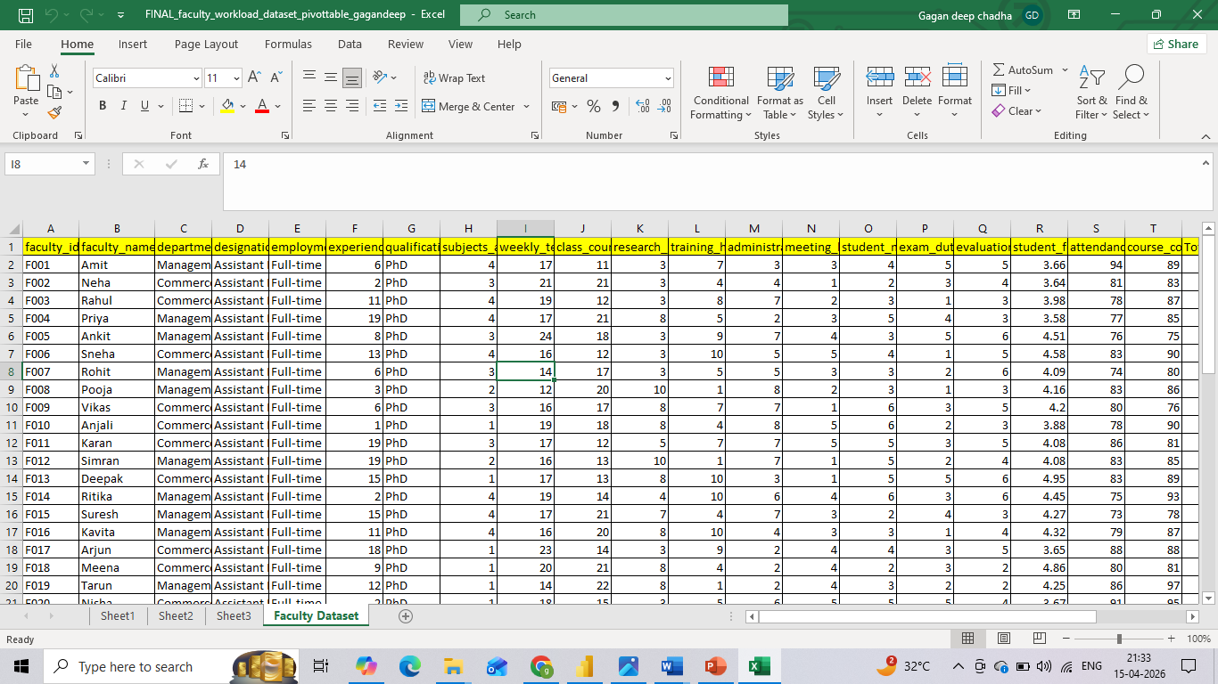

Appendix B — Key Excel Formulas
• =SUM(B2:G2) — used to calculate Total Workload by summing all workload components such as teaching, research, administrative, mentoring, and evaluation hours.
• =IF(H2>40,"Overloaded","Balanced") — used to determine Workload Status based on total workload threshold.
• =H2/40*100 — used to calculate Workload Percentage relative to standard workload hours.
• =AVERAGE(range) — used to compute average workload across faculty members for comparison.
• =COUNTIF(range, criteria) — used to count number of faculty members falling into specific categories (e.g., overloaded).
• =IFERROR(formula,0) — used to handle errors in calculations and ensure clean output.
• Pivot Tables (Excel) — used for summarizing workload data by faculty, department, and activity type.
• Power BI DAX:
- Total Workload = SUM(Faculty[Total_Workload]) — used to calculate total workload in dashboard
- Average Workload = AVERAGE(Faculty[Total_Workload]) — used for comparison metrics
- Overloaded Count = COUNTROWS(FILTER(Faculty, Faculty[Status] = "Overloaded")) — used to count overloaded faculty

Appendix C — AI Prompts Used
• Prompt 1:
"Analyze the faculty workload dataset and identify faculty members who are overloaded based on total workload and workload percentage."
• Prompt 2:
"Summarize the key insights from the faculty workload data, highlighting workload distribution and major contributing factors."
• Prompt 3:
"Identify patterns or trends in workload distribution across different faculty members and departments."
• Prompt 4:
"Suggest strategies to balance workload among faculty members based on the given dataset."

Appendix D — Screenshot Gallery
